function binarySearch(arr, target)

{

let start = 0;

let end = arr.length - 1;

while (start <= end) {

let mid = Math.floor((start + end) / 2);

if (arr[mid] === target) {

return mid;

} else if (arr[mid] < target) {

start = mid + 1;

} else {

end = mid - 1;

}

}

return -1;

}

const Array = ['anu', 'bala', 'jaya', 'kalai', 'kavi', 'arun'];

const target = 'kavi';

const index = binarySearch(Array, target);

if (index > 0 ) {

console.log(`The string is found at index ${index}.`);

} else {

console.log (`The string is not found in the array.`);

}

Output:

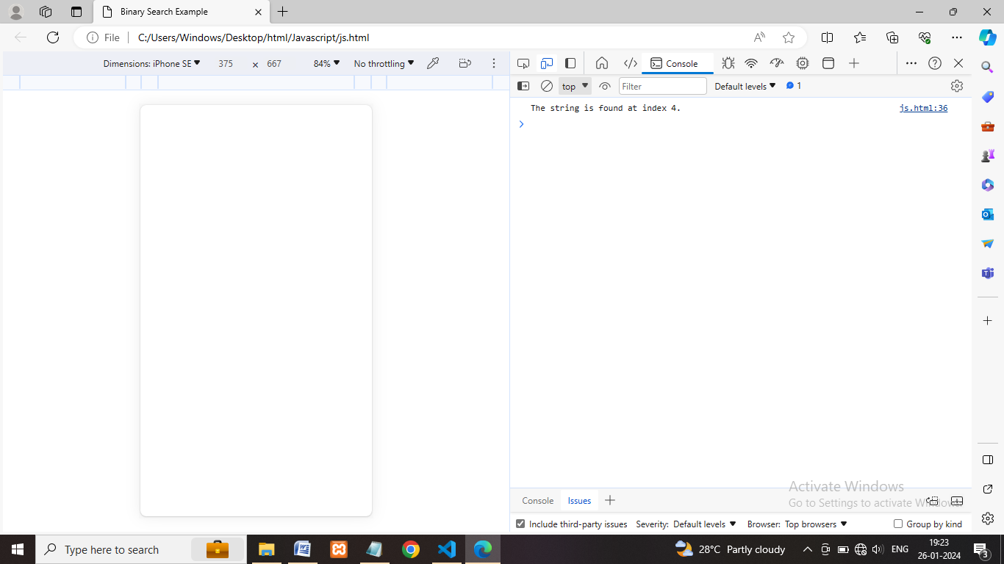

Description:

I implement the concept for find the string in the given array, use this concept in req and res to

Find the user name is already in array or not. the target value (it’s take currently entered username)

First its divided the array of 2 start and end key points, the first condition is **if (arr[mid] === target)**

Compare the mid value to the target value it’s true means return mid value otherwise check the next

condition this condition left search 0 < 1 the left side target value not found means check the right

side 0 > 1 once the target value found it’s return -1.